ASS#2 Step 7 – Contribution Margin
Contribution Margin – the calculation process
Initially this step concerned me. Not the mechanics of it, as Contribution Margin is a simple calculation of Sale – Variable Costs, the concern was more about what information can be used to carry out this step in the assignment effectively. GallifordTry has three operating units, Lindon Homes, Partnerships & Regeneration and Construction. Linford Homes builds a range of Private Homes and Affordable Homes, Partnerships & Regeneration work with housing trusts and local councils to build and refit/repurpose a range of dwellings and Construction does large infrastructure projects. The question was how to pick a product/service from this mix that is relevant and would give a reasonable indication of contribution margin and to do this without guessing. There was information in the 2018 report that would surely point the way, but initially I could not see it. Inspiration came, as it generally does, when out running, and I could see a way forward.
The annual report details the performance of each business unit. This includes the average price of the land purchased for the company land bank, the total number of homes built by both Lindon Homes and Partnerships and Regeneration along with the average selling price. The final piece of the puzzle was the gross contribution made to the group by these parts of the business. Ideally, I would have like to have found similar information for the Construction group. However, the report makes it clear that the contribution of construction is considerably less than the house building parts of the firm. To make it easier for me I have not considered the construction group in this exercise.
I’ve taken a relatively simple approach and added a few assumptions in my calculations and the calculations can be seen in the table at the end of this document. The number of units sold are categorised as affordable homes, private homes and partnership and regeneration. These are three very different sectors of the UK housing industry. In every new development there is the expectation that the developer will build a mixture of “high end” and entry level housing. This is the difference between private and affordable and that is reflected in the size, fit out, location and selling price of these houses. The financial report detailed that the average selling price for a private house is almost three times that of an affordable home. To obtain an estimate of the variable cost I have taken the average land price from the financial report and subtracted that from the sale value. This gives an indication of the total construction cost. However, from the reports GallifordTry does report an averaged declared Gross Margin at 23%.
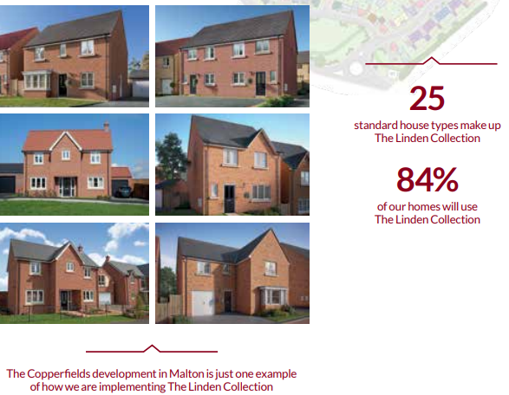
Working with a building firm as part of my day job, I am familiar with how the Brisbane builder is applying a margin to our project. In this exercise I have assumed that this 23% gross margin will be applied to the selling price. To obtain the variable cost I have taken the gross margin value from construction cost to give what I think is a reasonable figure for the estimated variable cost.
The variable cost for affordable homes does seem quite inexpensive, however after looking at the company reports, GallifordTry obtain several synergies and cost savings from doing a range of similar designed homes with common fit outs. It is possible that the gross margin for affordable homes would be less as well. There is a difference between the affordable home design and the private home design, and this would be reflected in the variable cost for the private homes. The private homes are larger with extra detailing and higher quality fit out which would account for the increased variable costs. GallifordTry do have a range of private homes and obtain savings from similar designs and fittings.
I have applied the same process to the Partnerships & Regeneration part of the GallifordTry business. This is a different business model where GallifordTry works with local government and housing trusts in development projects.
What does the contribution margin tell us?
These calculations do seem in line with the details in the annual reports. These two operations of GallifordTry are the cash engine of the firm and create the funding needed for continued rapid growth activities of house building. As would be expected private homes and partnerships & regeneration have the highest contribution margin. I would consider that GallifordTrys preferred approach would be to increase the number of private homes and partnerships & regeneration sales as these do have the best contribution margin. In both operations there is either a direct sale to a new homeowner or a sale to a housing trust. In looking at the figures I suspect GallifordTry would be comfortable with the contribution that these operations are making to the firm. There is an acute shortage of housing the UK and indications from the annual reports that there are enough sites in the landbank and financial inducements for buyers to continue this type of operation comfortably for a number of years to come.
Possible constraints
GallifordTry are aware of potential constraints and detail these in the annual reports. Since the 2018 report was published Brexit continues to be unresolved and with it the future of skilled workers from the Euro Zone. Recently the firm has had a change of CEO that may have an impact, the new CEO is an internal appointment which may reduce the transition period. Recent press reports indicate that there are issues within the UK construction industry which are impacting the construction arm of the firm. On 19th April GallifordTry issued a profit warning following the announcement of more exceptional costs related to a project in Scotland. Another construction firm in the UK, the Kier Group, posted half-year losses of £35.5million per month, further indicating that the construction sector in the UK has significant challenges. With this uncertainty in the construction sector GallifordTry may hope to further rely on the home building and regeneration operations to remain profitable. GallifordTry are in a good position to increase their homebuilding operations and they have been increasing the output year on year. The planning and approvals process as dictated by central and local governments are a constraint in this growth pattern, this was also highlighted in the 2018 report.
Conclusion
Within its three operating units GallifordTry have two very profitable operations in Lindon Homes and Partnerships & Regeneration. These businesses have increasing revenue year on year, very good contribution margins and operate in an area of need and growth within the UK economy. It will be interesting to see what the impact of the challenges in construction have on the firm’s performance and if the continual political instability within the UK is resolved satisfactorily to provide a benefit to the firms performance.

Contribution Calculations.
 | Number of Units Sold in 2018 | Average Selling Price | Average Price of Land (Fixed Cost) p34 2018 Annual Report | Construction Cost = Selling Price - Land Price | Average Declared Gross Margin 23%  (p28 2018 report) | Estimated Variable Cost =  Construction Cost - Gross Margin | Contribution Margin per unit
Affordable Homes | 853 | £134,000.00 | £69,000.00 | £65,000.00 | £30,820.00 | £34,180.00 | £99,820.00
Private Homes | 2587 | £367,000.00 | £69,000.00 | £298,000.00 | £84,410.00 | £213,590.00 | £153,410.00
Partnerships & Regeneration | 751 | £220,000.00 | £90,000.00 | £130,000.00 | £50,600.00 | £79,400.00 | £140,600.00

